

PROCESS
Management Review

Code | 05e-QT/CL/HDCV/FSOFT
Version | 1/2
Effective date | 01/06/2010

Table of content
1 INtroduction 3
1.1 Purpose 3
1.2 Application Scope 3
1.3 Definitions 3
1.4 Related Documents 3
2 Process 4
2.1 Work flow 4
2.2 Process Description 5
2.3 Roles and Responsibility 5
2.4 Work Product 5
2.5 Metrics 5
2.6 Record 5
3 Procedure 7
3.1 Develop Management Review Program 7
3.2 Preparation, Reports 7
3.3 Conduct Management Review Meeting 8
3.4 Follow up 9

INtroduction

Purpose
This document to provide steps on how to conduct management review meetings at levels (company, subsidiary company/branch, departments, projects) on periodic and event-based basis to
- Provide appropriate understanding, visibility of the organization performance that enables corrective/preventive actions taken timely
- Ensure conformity, effectiveness and continuously improvement of Fsoft management system

Application Scope
This process is applied in FPT Software Joint-Stock Company.

Definitions
Abbreviations | Description
N/A

Related Documents
No | Code | Name of documents
 | 01e-QT/CL/HDCV/FSOFT | Process_Quality Planning
 | 04e-QT/CL/HDCV/FSOFT | Corrective and preventive action
 | 03e-QT/CL/HDCV/FSOFT | Process_Internal Audit
 | 02e-QT/CL/HDCV/FSOFT | Process_QA Control
 | 10e-QT/CL/HDCV/FSOFT | Process_Organization Improvement & Deployment
 | 09e-QT/CL/HDCV/FSOFT | Process_Organizational Process Performance Management
 | 02-HD/HC/HDCV/FPT | HDCV_To chuc hoi nghi, hoi thao

Process

Work flow
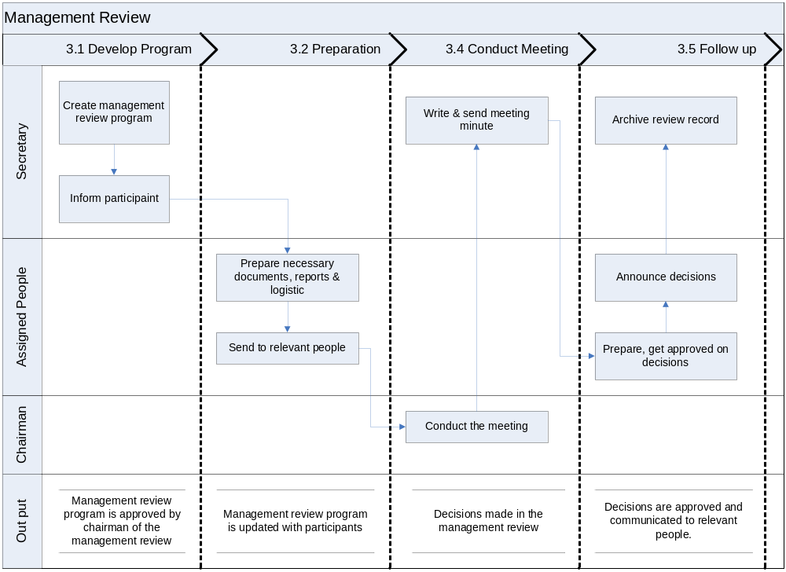

Process Description
No | Entry Criteria | Activity | Exit Criteria
1 | Decision/Plan for management review is available | Develope management review program | Management Review Program is created and confirmed with relevant people
2 | Management review program is base-lined | Preparation, reports | Supporting documents, reports necessary  Participants are notified with the program
4 | Management review program is base-lined  Necessary documents, reports are prepared | Conduct review meeting | Management review meeting is conducted
5 | Record of management review meeting is created. Decisions made in management review meeting are released | Follow up | Relevant people are communicated with the decisions.

Roles and Responsibility
Refer to section 3.

Work Product
- Management Review Program
- Documents/Reports to present/discuss in the management review meeting
- Meeting minute & Decisions made in the management review meeting

Metrics
No | Metric Name | Purpose | Unit | Formula
 | Number of decision done completely | To measure efficiency of management review | % | >=75

Record
No | Name of Records | Storage Modality | Duration | Important Level | Location
 | Management review program | Soft | 3 years | Medium
 | Management review meeting minutes | Soft | 3 years | High
 | Decisions made in the management review | Soft | 3 years | High
 | Necessary documents, report used for the meeting | Soft | 3 years | High

Procedure

Develop Management Review Program

Purpose
To identify objectives, agenda and participants of management review & ensure all participants, relevant people aware of their involvement in the management review.

Trigger
- For quarterly meeting at Fsoft level: at least 7 days before management review date
- The other management review meeting: 3 days before management review date

Inputs
- Management review plan

Steps
- Unit’s secretary to prepare management review program. Then get it reviewed with relevant people and approved by Chairman of the management review.
- Inform participants about their involvement in management review program.

Outputs
- Management review program is approved by chairman of the management review.

Preparation, Reports

Purpose
To consolidate data, prepare documents, report that will be used over management review to support decision making process.

Trigger
- As per defined in management review program
- As per management review program

Inputs
- Management review program

Steps
- Related people prepare necessary documents, reports as assigned in the management review program.
- Report on the following topics is mandatory required for the management review at Fsoft level and SC/Branch level every 6 months.
  - Progress of the last management review meeting’s decisions
  - Actual performance and result vs. annual objectives/target & plan
  - Product's conformity
  - Customer feedback and complaints
  - Corrective/preventive actions
  - Internal audit result
  - Changes affecting to the management system
- Assigned persons send the management review program to relevant people, participants, remind frequently, and distribute documents to the participants as necessary.

Outputs
- Management review program, necessary documents are sent to the people
- Participants are updated with the management review program

Conduct Management Review Meeting

Purpose
To review on the accomplishment and results of the organization

Trigger
As per management review program

Inputs
- Management review program

Steps
- Chairman of the management review appoints secretary of the meeting and introduce the management review agenda
- The management review is conducted according to the program. The content includes, but not limited to:
  - Identify management system requirements and their effects to FSOFT Management system in the future.
  - Identify improvement areas, necessary changes and actions to improve Fsoft management system and products/services
  - Identify necessary resources
  - Discuss other issues and define solutions, if needed
- The secretary prepare meeting minutes of the management review, get it approved by the chairman and then distribute to all participants

Outputs
- Management review meeting minutes
- Decisions made in the management review

Follow up

Purpose
To ensure the decisions are communicated to relevant people

Trigger
For quarterly management review at Fsoft level: 7 days after the meeting is maximum

Inputs
- Management review meeting minutes

Steps
- Assigned persons prepare decisions, get those approved by authorized persons. Then issue and announce the decisions to relevant people
- Secretary archives management review records in defined repository.

Outputs
- Decisions are approved and communicated to relevant people.

Approver | Reviewer | Creator
Bui Thi Hong Lien | QA | Nguyen Thi Thu Ha

Activities at this step must be fully performed with periodical management review meetings. Extra-ordinary management meetings are held depending to approved program
The decisions making is independent with the management review meeting minutes based on real need and decided by the Manager

